Software Requirements Specification
for
Sociogram
Version 1.0
Prepared by
Yukta Wagh
Aayush Juhukar
Drishti Agrawal
Fr. C.R.C.E
16th August, 2022
Table of Contents
Table of Contents ii
Revision History ii
1. Introduction 1
1.1 Purpose 1
1.2 Document Conventions 1
1.3 Intended Audience and Reading Suggestions 1
1.4 Product Scope 1
1.5 References 1
2. Overall Description 2
2.1 Product Perspective 2
2.2 Product Functions 2
2.3 User Classes and Characteristics 2
2.4 Operating Environment 2
2.5 Design and Implementation Constraints 3
2.6 User Documentation 3
2.7 Assumptions and Dependencies 3
3. External Interface Requirements 3
3.1 User Interfaces 3
3.2 Hardware Interfaces 3
3.3 Software Interfaces 4
3.4 Communications Interfaces 4
4. System Features 4
4.1 System Feature 1 4
4.2 System Feature 2 (and so on) 4
5. Other Nonfunctional Requirements 5
5.1 Performance Requirements 5
5.2 Safety Requirements 5
5.3 Security Requirements 5
5.4 Software Quality Attributes 5
5.5 Business Rules 5
6. Other Requirements 6
Appendix A: Glossary 6
Appendix B: Analysis Models 6
Appendix C: To Be Determined List 6

Revision History
Name | Date | Reason For Changes | Version

Introduction

Purpose
This app gives an opportunity for people who are far from each other, this application gives them the opportunity to connect with each other and share different thoughts with people sitting in every corner of the world. Users can connect with other people also and follow their life in posts. Make new friends and interact with each other.

Document Conventions
<Describe any standards or typographical conventions that were followed when writing this SRS, such as fonts or highlighting that have special significance. For example, state whether priorities for higher-level requirements are assumed to be inherited by detailed requirements, or whether every requirement statement is to have its own priority.>

Intended Audience and Reading Suggestions
This website is targeted towards all age groups but specifically for young adults as they are the pertinent users of these social media platforms. This document can be read by all stakeholders including the development team, project manager, team leads, testing team to better understand the software requirements.

Product Scope
Sociogram is an online messaging website where the users can interact with their friends. Users can register/login on the website and make new friends.

References
WhatsApp: https://web.whatsapp.com/

Facebook: https://www.facebook.com

Overall Description

Product Perspective
This social networking platform allows user to connect with their family and peers across the world through messaging. The user just needs to login and verify himself with OTP. This is an independent product and will be the first release of the product.

Product Functions
The user can register by feeding his personal details such as name, DOB, age, mobile no, email id etc. it can set the username and the password. These credentials will be stored in the product’s database and will be used to check for authenticity for further logins. The user can make new friends and can even chat with them. The details will only be visible if there is any connection between the user and the other person.

User Classes and Characteristics
User needs to register for using the messaging service. For registration, user needs input name, username, password, DOB which ensures he is of correct age (16+) to use the service. Account will be verified through one time password (OTP). For login, user will input username and password created.

Class | Characteristics
Register | Takes personal details and user can set username and password
Login | User can login with set username and password
Authentication | All registration and logins will be verified
Chat | User can send/receive messages
Add Friend | User can add friends by sending them requests
Forgot Password | User can set new password after identification

Operating Environment
Hardware
PC/mobile

Software
Chrome/Internet Browser/Safari/Android
Windows/MacOS
Programming language: HTML, CSS, Javascript

Design and Implementation Constraints
This website supports English language only and is viewed best on google chrome.

User Documentation
N/A

Assumptions and Dependencies
- User must have 3G, 4G or Wi-Fi
- User should have a valid email address in order to register

External Interface Requirements

User Interfaces


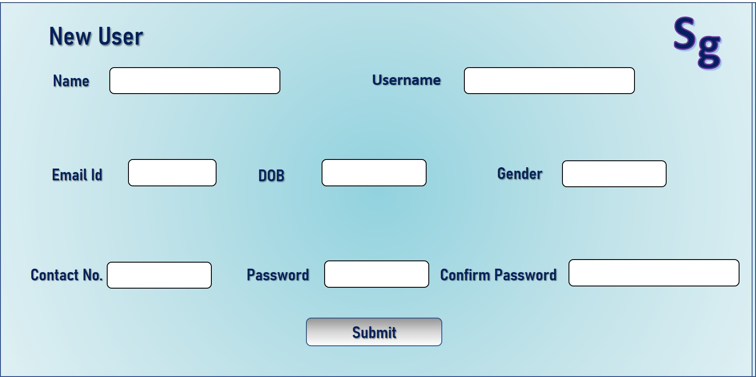

3.2 Hardware Interfaces
N/A

Software Interfaces
Email Interface

Captcha Service Interface
Captcha services will be used for human identification

communications Interfaces
Networking protocol: HTTP
Network Server communication protocol: TCP
Browser: JavaScript enabled browser

System Features

System Feature 1
Name - User Registration
Description - user will create an account if he/she doesn't have any existing account associated with his/her details. User should enter account details like Name, user name, email-id, contact number, Date of birth, password. All of these fields are necessary, and account creation cannot move on without them being completed. After this information has been verified and the user has accepted the terms and conditions, the user is registered. User must be 18 years or more. Contact no should be 10-digit numeric field. First and last name should not be more than 20 characters each. Password should be atleast 8 character long, atmost 12 characters including atleast one upper case, one lower case, one special character and a number.

System Feature 2
Name - login
Description - User must be registered in order to login. Input will be the user name and password for login. The hash of password should match to the hash of password stored in the database. After password, captcha should appear.

System Feature 3
Name - Add friend
Description - A registered user should be able to send friend requests to other users and connect with them. User can send friend request to already registered users. User can search his friend among the registered users and then send a friend request to him/her.

System Feature 4
Name - Chat
Description - Users should be able to chat with their friends form their friends list. The other user should seamlessly understand that the chat has been initiated. Users should be able to receive messages from anyone in their friends list online. The receiving entity can therefore send the message back to the originator, completing a two-way conversation.

Other Nonfunctional Requirements

Performance Requirements
- System should be able to handle large number of users.
- Speed should be fast to provide seamless lag-free experience.

Safety Requirements
N/A

Security Requirements
- During user registration, the provide contact no. will authenticated using OTP.
- Password should be atleast of 8 characters consisting of atleast an uppercase and lowercase letter and number and special symbols.
- Password is stored as Hash value in database
- Data is encrypted as this website uses HTTPS

Software Quality Attributes
- The website interface should be user-friendly
- The system should be available all time and to be ensured that there is no downtime
- System should be reliable and user information should be stored without any modification
- Security of the data should be top priority
- Delay between messages should be as low as possible.
- The system should be testable at all stages to allow constant improvements

Business Rules
N/A

Other Requirements
<Define any other requirements not covered elsewhere in the SRS. This might include database requirements, internationalization requirements, legal requirements, reuse objectives for the project, and so on. Add any new sections that are pertinent to the project.>
Appendix A: Glossary
<Define all the terms necessary to properly interpret the SRS, including acronyms and abbreviations. You may wish to build a separate glossary that spans multiple projects or the entire organization, and just include terms specific to a single project in each SRS.>
Appendix B: Analysis Models
<Optionally, include any pertinent analysis models, such as data flow diagrams, class diagrams, state-transition diagrams, or entity-relationship diagrams.>
Appendix C: To Be Determined List
<Collect a numbered list of the TBD (to be determined) references that remain in the SRS so they can be tracked to closure.>

